**9+**

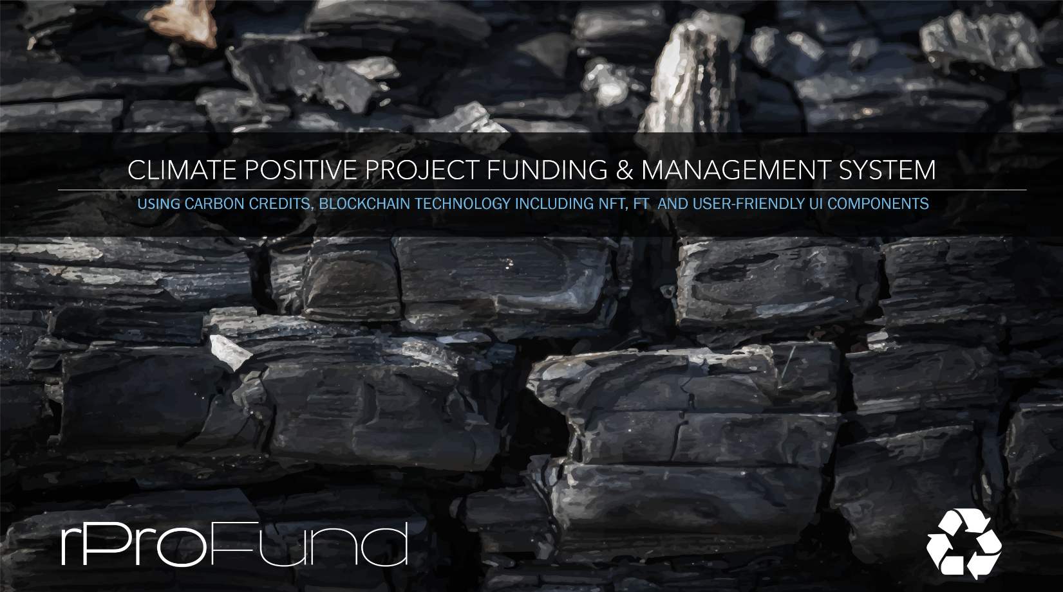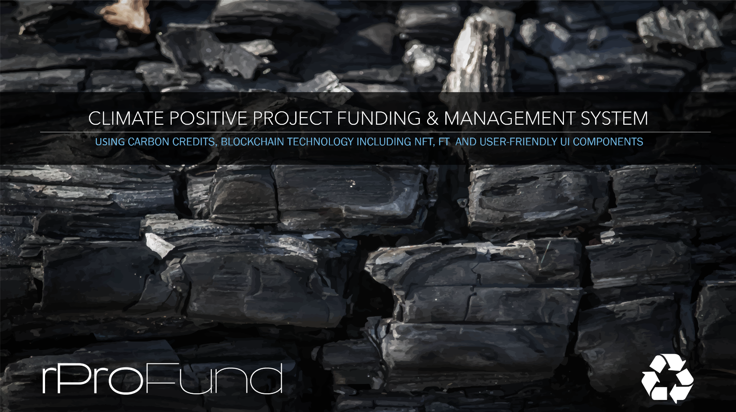

**WHITE PAPER (DRAFT)**

**rProFund Submit to Accumulate**

**The Problem:**

How do all of the participants in a Scalable Climate-Positive Project Answer the following Questions:

* What are the Invested/funded monies used for?
* How do we verify that the project, as proposed, IS actually climate-positive?
* Is a functioning project actually achieving its goals including its climate-positive goals?
* Is a project profitable?
* Who owns/who funded the project?
* Who is entitled to distributions from the project?
* How do we provide liquidity for participants?
* How does the project provide transparency/third party auditability?
* How do we maintain security?
* How do we create liquidity for project owners?

There are many projects out there trying to answer these questions via project tracking, Carbon Credit tokenization and tracking and fractionalization/ownership modeling systems. None of the Web2, or Web3 applications that we have found, by themselves, answer all of these questions or provide an efficient solution that answers these questions.

If we are truly going to facilitate and manage these projects efficiently and make a real climate-positive difference, we need to have clearly defined objectives, community buy-in, investor buy-in, trackability, flexibility and 3rd party auditability at a bare minimum.

**Solution Approach:**

Our goal is to answer these questions, and facilitate a better world to live in while implementing the process. To accomplish this, we must:

* Involve the local and global community.
* Provide flexibility so that each project’s ecosystem will have the ability to adapt to real life challenges and changes that are inevitable as a project evolves.
* Set measurable goals for the project including quality of service to the community, actual trackability of each project’s climate impact, and profitability.
* If carbon credits are being utilized to fund the project, partially or fully, we must have the ability to verify that the project is actually offsetting carbon into the future and verify that the money spent to purchase the carbon credits is actually used to produce the carbon offsets.
* If a project, who’s main objective is not traditionally climate positive, is committing to offset its own carbon footprint, we need to track it and make sure that the project IS actually climate positive.
* All of this must be third-party verifiable and auditable in order to determine these measurements of success.
* Above all there must be transparency and accountability.

**Capabilities that need to exist for each project in order to accomplish the above stated goals.**

* Trackability of money as it goes into the project.
* Ability to create, hold and sell carbon credits.
* Ability to facilitate private Investment.
* Ability to facilitate grants both private and governmental.
* Ability to create, hold, and pre-sell carbon credits that have been registered but not issued. This will allow us to facilitate, create and maintain their utility.
* A place to hold, document, and identify ownership of assets (any asset described herein).
* A place to put incoming money in the project that provides visibility for how the money is spent.
* A record of the origin of all project assets including money, and a chain of ownership (audit trail).
* Liquidity for all assets.
* The ability for any person or entity, large or small, to participate and have the same visibility into their participation success.
* The ability to collect profits/distributions/income for the project and manage it within the project.
* The ability for a project to hold/own either whole or fractionalized investments of its own that each have all of the above abilities.
* The ability to distribute what is produced by and held within a project.
* The ability for each project to be/have its own identity with the same abilities as any individual/entity that would have its own assets, and wallets, signature etc.
* Security that deters dishonest activity.

***Blockchain technology is the perfect vehicle to provide these capabilities.***

Assets/Objects/Tokens/Data groups needed for implementation

* Master Asset Identity/ADI
  + Has Fungible tokens associated with it
  + Associated with a Project Identity/ADI or fraction thereof for asset backed value
  + Has a value calculated using the Asset Values tied to the Project Token/Fraction associated using Value as a Service when possible.
  + When fractions are spent, they carry fractionalized prorated ownership along with the Fungible Token amount spent.
  + This allows Fungible tokenization of any asset or group of assets associated with a Project Token or fraction thereof. These can be fractionalized via creating new Master Token/Project Token fraction pairs representing the amount spent further fractionalizing the Project token associated.
  + Will have any combination of identities below as sub-identities associated with it.
* Project Identity/ADI
  + Non-fungible Asset/token as sub-Identity chain, with the ability to fractionalize ownership
  + Has a calculated value based on the underlying associated Assets using Value as a Service and Accumulated Value as a Service of Sub-identities/chains.
  + All Web3 functionality will depend on the relationships and sub-identities associated with the project.
  + This Project Identity has one Wallet Group associated with it as a sub-identity.
  + This Project has an identity that is unique and has a signature page. (can contain multiple authorities so that multiple signatures with different security levels can be required for each type of transaction).
  + Will have a group sub-identities/ADI containing all associated transactions for this Project.
* Wallet Group
  + Can contain multiple other Wallet groups as sub-identities.
  + Can contain Project Identities as sub-identities of the project or projects within a project.
  + Can contain Master Asset Identities as sub-identities.
* Information/Data collection/Data system/Data smart contract/Data object
  + Can contain Data Identities that are References to Oracle encoded Jason data
  + Can contain sub-identities that contain scratch-data associated with parent data identities.
  + References Data on and off chain.
  + Can be Valued as an Asset maybe even with Value as a Service providers.
* Transaction Group Identity/ADI
  + Project Transaction sub-identities that represent multiple types of transactions associated with a Project/and/or Asset.

All of the abilities listed above can be further enhanced via the program structures within the rProFund ecosystem. Each of the above objects will have an option of having an associated event driven smart contract(s) associated with it potentially another sub-identity identifying the associated smart contract. Each smart contract can also can affect multiple objects/Assets/tokens associated with it. In other words, each smart contract will have the ability to effect/control/access any asset/wallet/data management asset nested within the asset/project it is a sub-identity of.

**rProFund Practical Implementation of the Described Architecture**

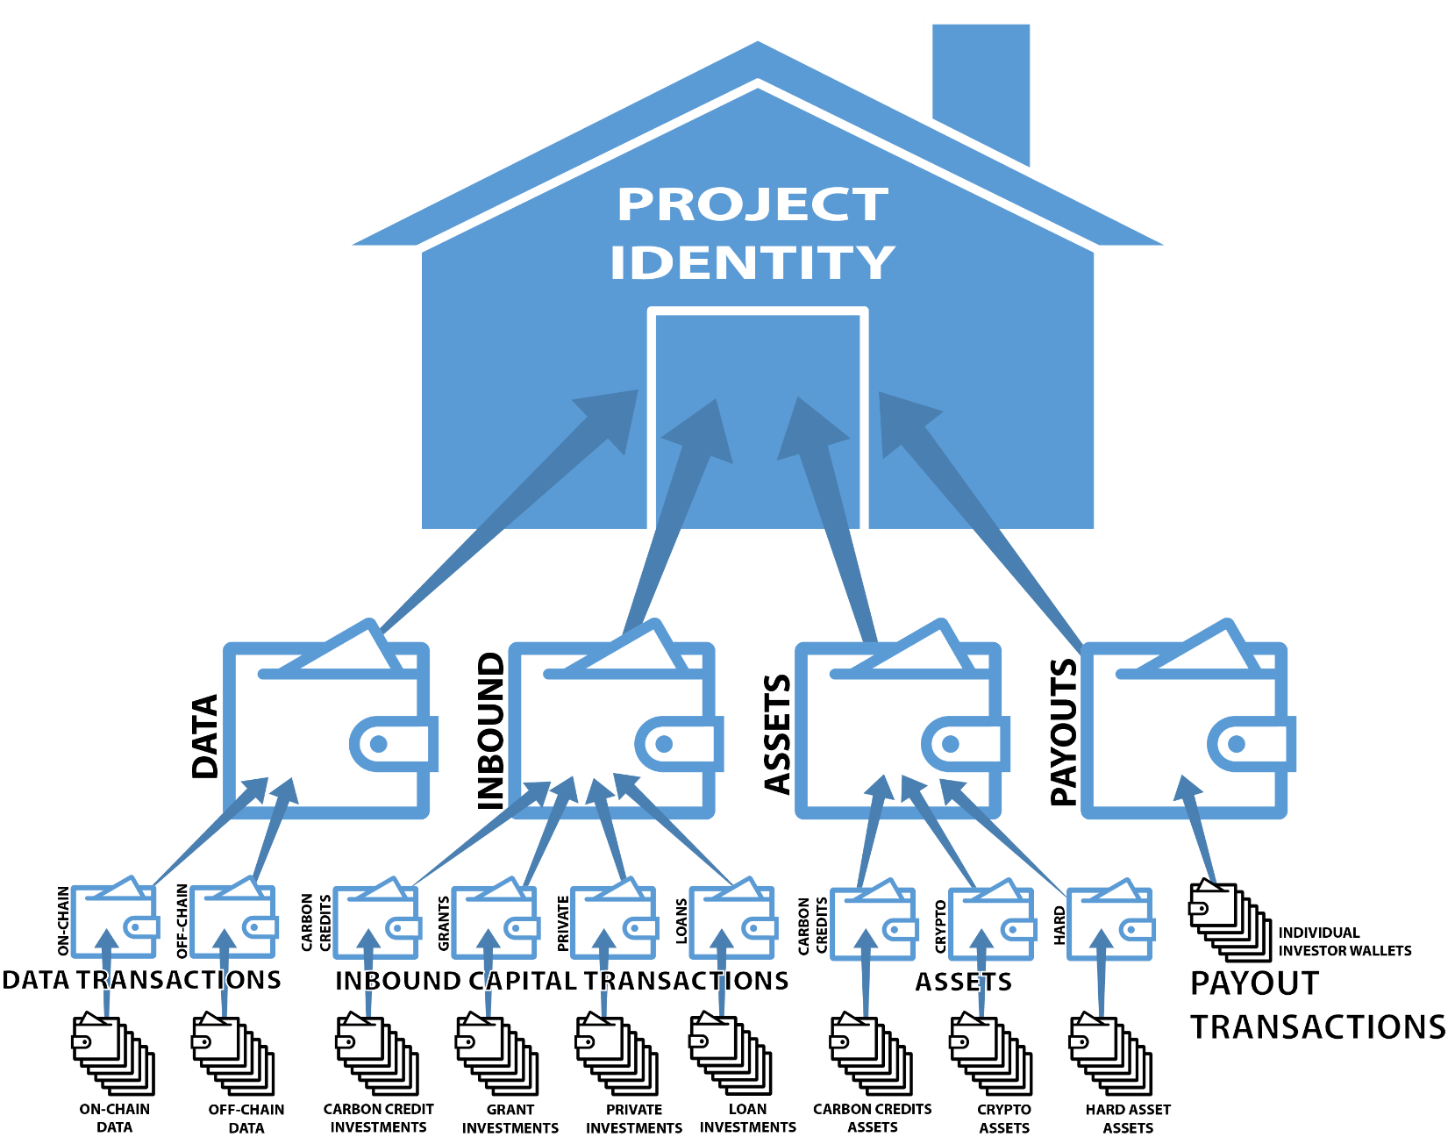

# END WHITE PAPER